W-20

**YEAR 12 PHYSICS**

**ASSIGNMENT 3 - MOMENTS & EQUILIBRIUM**

**Name:** **Mark:**

1. A thin metal rod is bent into a right angle and hung on a nail from a wall, as shown in the diagram. Assume that there is no contact between the rod and the wall. The longer side (L2) is 0.800 m and makes an angle of 14.0° to the vertical. The rod has uniform density and constant thickness. Calculate the length of the shorter side, L1. Show all workings. (4 marks)

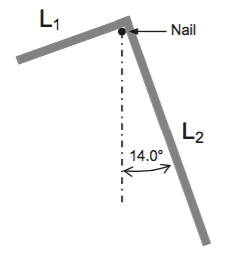

2. A large cat (*m* = 8.00 kg) is on a uniform 5.00 m long, 4.00 kg beam resting on two supports. Determine the distance from the end of the beam at which the cat will make the system unstable. (3 marks)

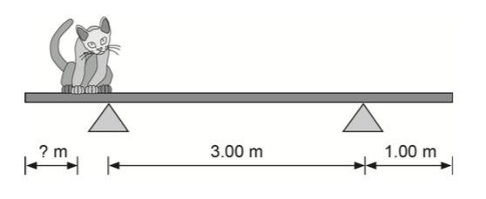

3. A window washer (*m* = 65.0 kg) is on a 5.00 m long, 15.0 kg scaffold supported by two ropes attached to it. The angle between scaffold and rope (θ) is 75.0°. Determine the tension in each rope. (5 marks)

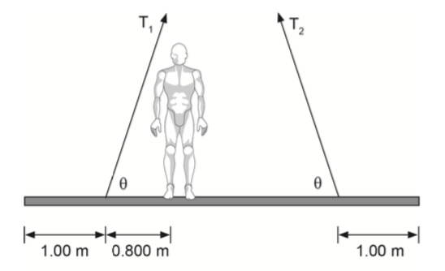

4. A truck transports a large 5.50 × 103 kg cylinder that has a radius of 2.00 m. The cylinder is fixed to the truck by four ropes, two on each side, on ring attachments as shown in the diagram below. If the maximum load on each of the ropes (*T*) is 5.50 kN, calculate the maximum allowable acceleration of the truck when it moves forward. (4 marks)

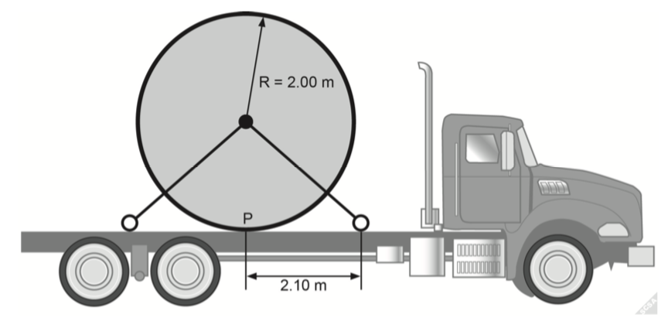

5. A 3.00 m long plank with a mass of 10.0 kg is held by a cable at Point P, 0.200 m away from the upper end of the plank. The angle between plank and ground is 20.0° and the angle between plank and cable is 30.0°. A 2.00 kg cat moves up the plank up to Point Q, 2.40 m from the bottom, Point O.

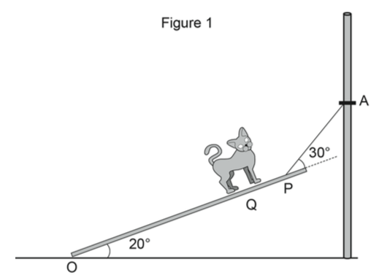

(a) Assuming that Point O is the pivot, calculate the tension in the cable. Show all workings. (6 marks)

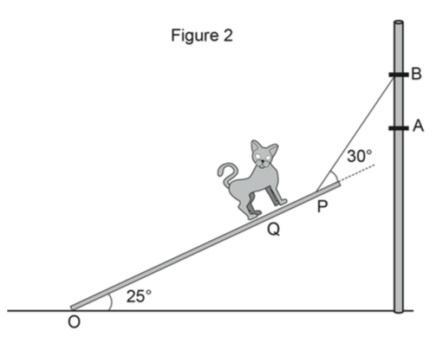

(b) The cable is then moved up from Point A to Point B while maintaining the angle between the plank and cable at 30.0°. The angle between the plank and ground increases to 25.0°, as in Figure 2. Assume Point O as the pivot.

(i) State whether the tension in the cable increases or decreases. (1 mark)

(ii) Justify your answer. (3 marks)

6. The diagram below shows a data projector with a mass of 7.00 kg. The projector is mounted on its uniform horizontal support arm at a distance of 0.500 m from the wall plate. The support arm itself is 0.900 m long and has a total mass of 1.00 kg.

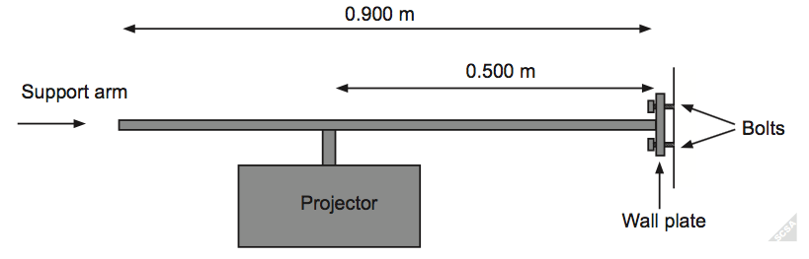

The assembly is held in place by bolts as shown in the diagram above. The upper bolt is 4.00 cm above the support arm and the lower bolt is 4.00 cm below the support arm. The wall plate does not touch the wall and is supported only by the bolts.

(a) Calculate the horizontal force in Newtons exerted by the upper bolt used to attach this projector to the wall. Show all workings.

Hint: Take the bottom bolt of the wall plate as a pivot point. (4 marks)

(b) Explain quantitatively the effect on the centre of mass of the projector/support arm system as the projector is moved further away from the wall. (3 marks)

(c) Explain quantitatively the effect on the horizontal force exerted by the upper bolt as the projector is moved further away from the wall, assuming the system maintains its stability. (3 marks)

7. A person climbs a ladder and holds a can of paint as shown in the photograph below.

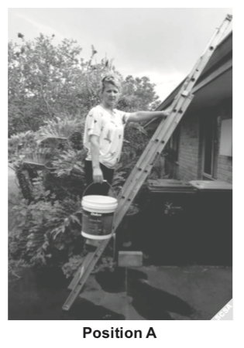

The ladder is 2.78 m long from the ground to the roof gutter of the house and rests on the gutter 2.40 m above the ground. The woman stands with her feet 0.500 m above the ground. The ladder has a negligible mass, the woman has a mass of 58.0 kg and the can of paint has a mass of 4.25 kg.

(a) Calculate the force that the roof gutter exerts on the ladder in Position A. Assume that this force acts at a right angle to the ladder. (7 marks)

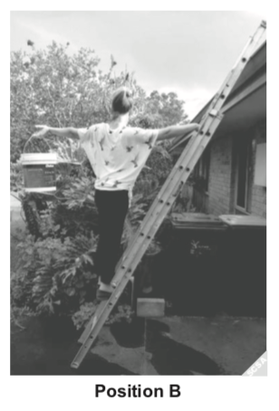

(b) Explain how the force exerted on the ladder by the roof gutter changes as the can of paint is moved from Position A to Position B (shown above). (3 marks)

(c) State whether the ladder and person are in equilibrium in Position B. Explain your reasoning. Calculations are ***not*** required. (4 marks)

(d) The ladder is then extended to form a 40.0° angle to the ground. The ladder is used as a ramp to pull a 35.1 kg box onto the roof by a rope parallel to the ladder. Calculate the tension in the rope if the box is stationary as shown. Assume that friction is negligible. (3 marks)

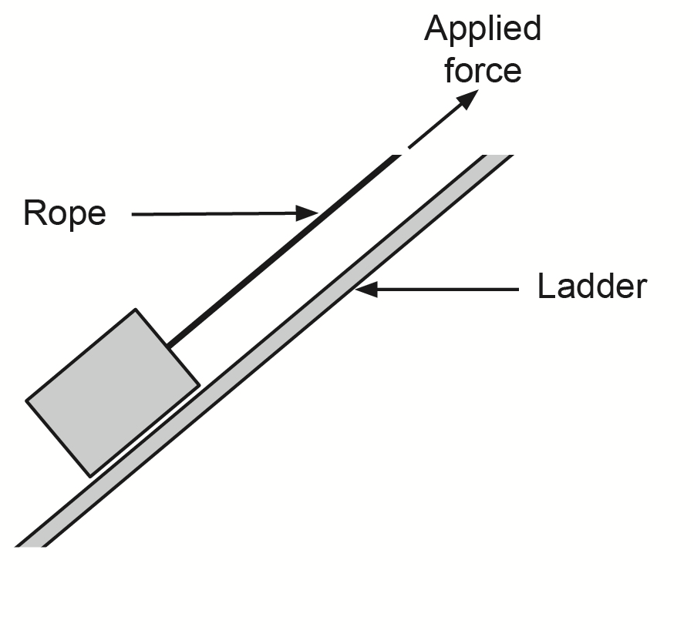

8. A uniform horizontal 2.50 m beam AD of mass 15.0 kg is attached to the front wall of a shop. It is strengthened and supported by a steel bracket BC that is attached to the beam AD at point B, 1.00 m from end D, and to the wall at point C, 1.00 m below end D.

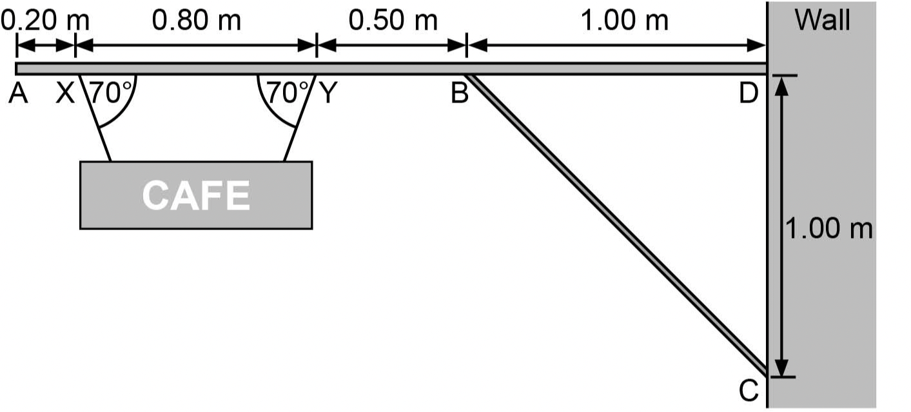

Beam AD supports a uniform sign of mass 4.00 kg. The sign is attached to beam AD at points X and Y using two light steel cables. They are 0.20 m and 1.00 m respectively from end A, both making angles of 70.0° to beam AD. The light steel cables are attached at equal distance from the centre of the sign as shown in the diagram above.

(a) Calculate the tension in each of the light steel cables supporting the sign. (3 marks)

(b) Calculate the compression force in the steel bracket BC, if the force only acts along BC. (4 marks)

9. Workers at an ice skating venue use a ladder to fix a sign 5.00 m above the surface of the ice.

To prevent the 6.00 m long ladder from slipping on the ice, they tie a cable between the ladder and the 4.00 m high wall. The cable is at right angles to the wall. The uniform 15.0 kg ladder is placed at an angle of 45.0° between the frictionless surfaces at A and B. A 90.0 kg worker is standing still on the ladder at G.

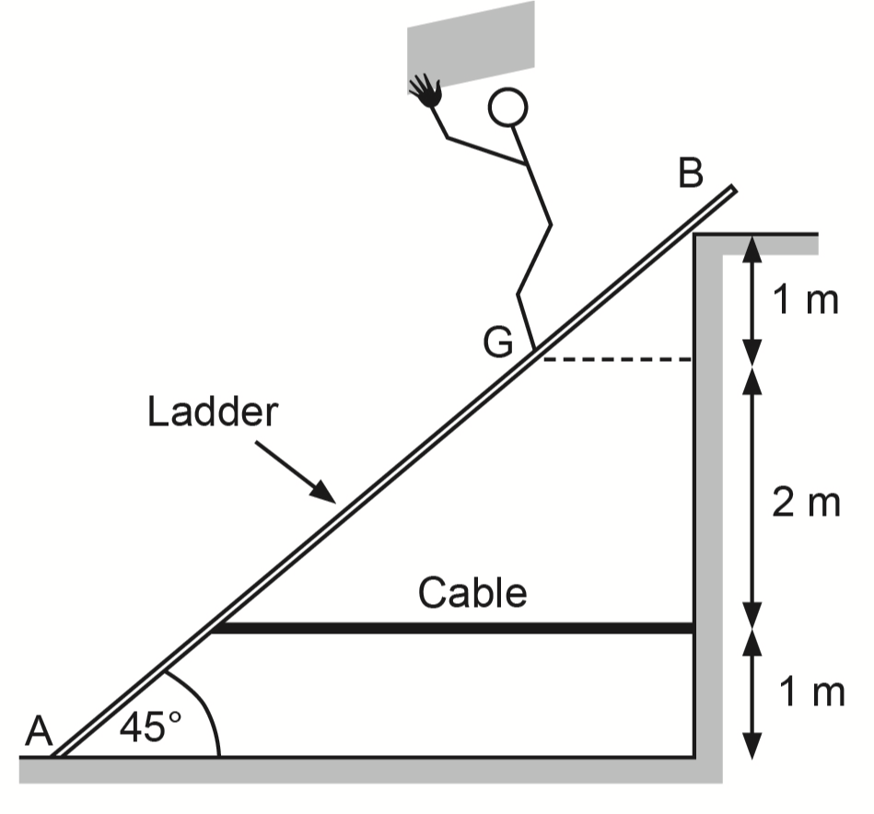

(a)   On the diagram above, draw and label the forces acting on the ladder. Assume the reaction force at B acts at right angles to the ladder. (4 marks)

(b)   By taking moments around A, calculate the tension in the cable. (6 marks)